**DDL Commands with Constraints – PRIMARY, FOREIGN KEY, UNIQUE, CHECK**

**AIM:**

To add the constraints like primary key, foreign key, unique key and check using DDL commands.

1) Alter the table STUDENT with following structure.

mysql> ALTER TABLE STUDENT ADD PRIMARY KEY(RegNo);

mysql> ALTER TABLE STUDENT MODIFY MobileNo int NOT NULL;

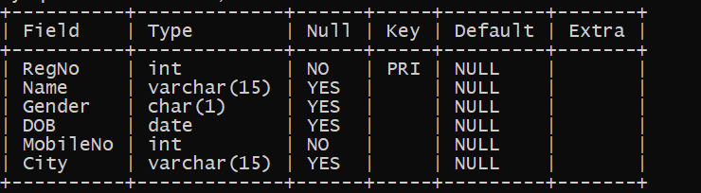

1. Alter the table name FACULTY with following structure.

mysql> ALTER TABLE FACULTY ADD PRIMARY KEY(FacultyNo);

mysql> ALTER TABLE FACULTY ADD CHECK(Gender='M'or'F');

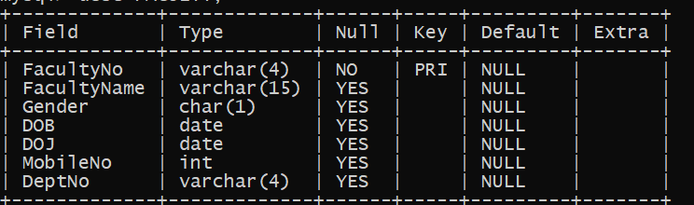

|  |  |
| --- | --- |
| 3) | After the FACULTY table is successfully created, test if you can add a constraint |
| FOREIGN KEY to the DeptNo of this table. | |
| 4) | Alter the table name DEPARTMENT with following structure. |

mysql> ALTER TABLE DEPARTMENT ADD PRIMARY KEY(DeptNo);

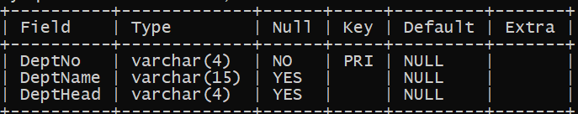

|  |  |
| --- | --- |
| 5) | Alter the table name COURSE with following structure. |

mysql> ALTER TABLE DEPARTMENT ADD PRIMARY KEY(CourseNo);

mysql> ALTER TABLE COURSE ADD CHECK(SemNo>=1&SemNo<=6);

